Task 1: Linked Lists, Stacks, Queues, and Priority Queues
Run the script linked_lists_practice.py for testing the simple python lists, single linked and double linked list data structure code and benchmark their performance for different data sizes. Report on the performance (screenshots)for each data size. Currently it is set for 1000. Test it for 10000 and 50000.
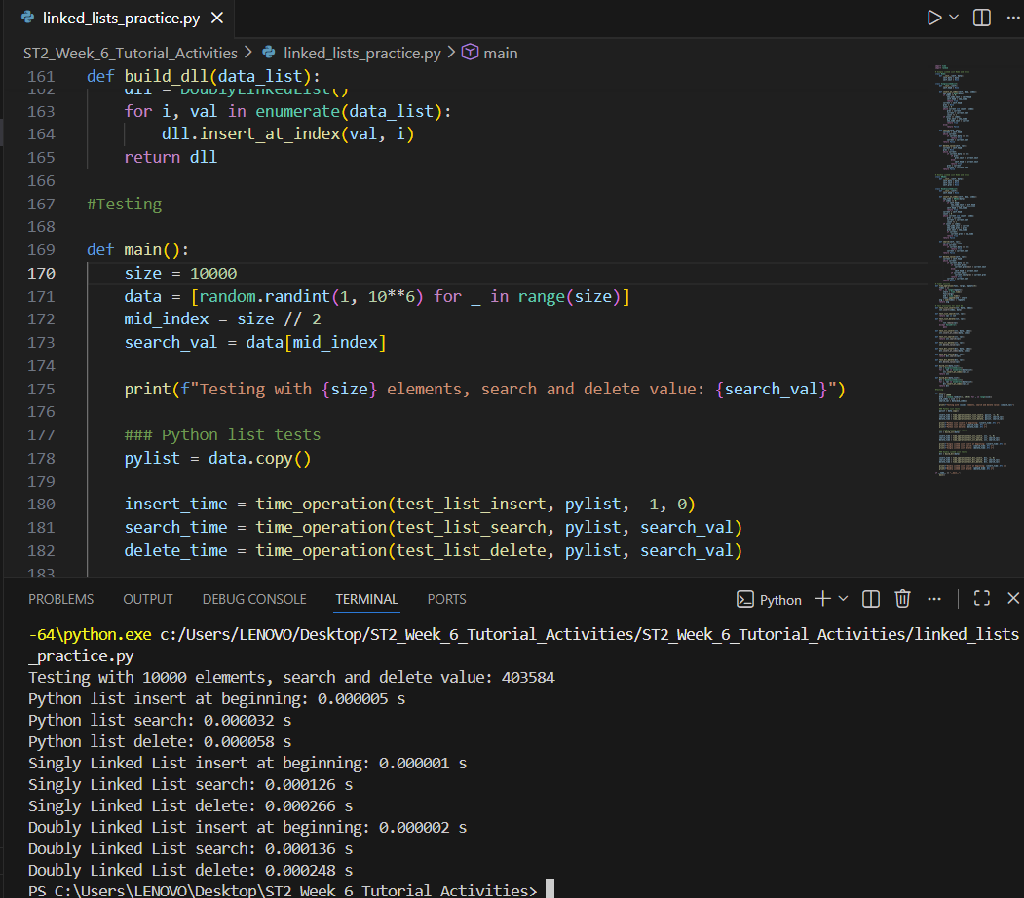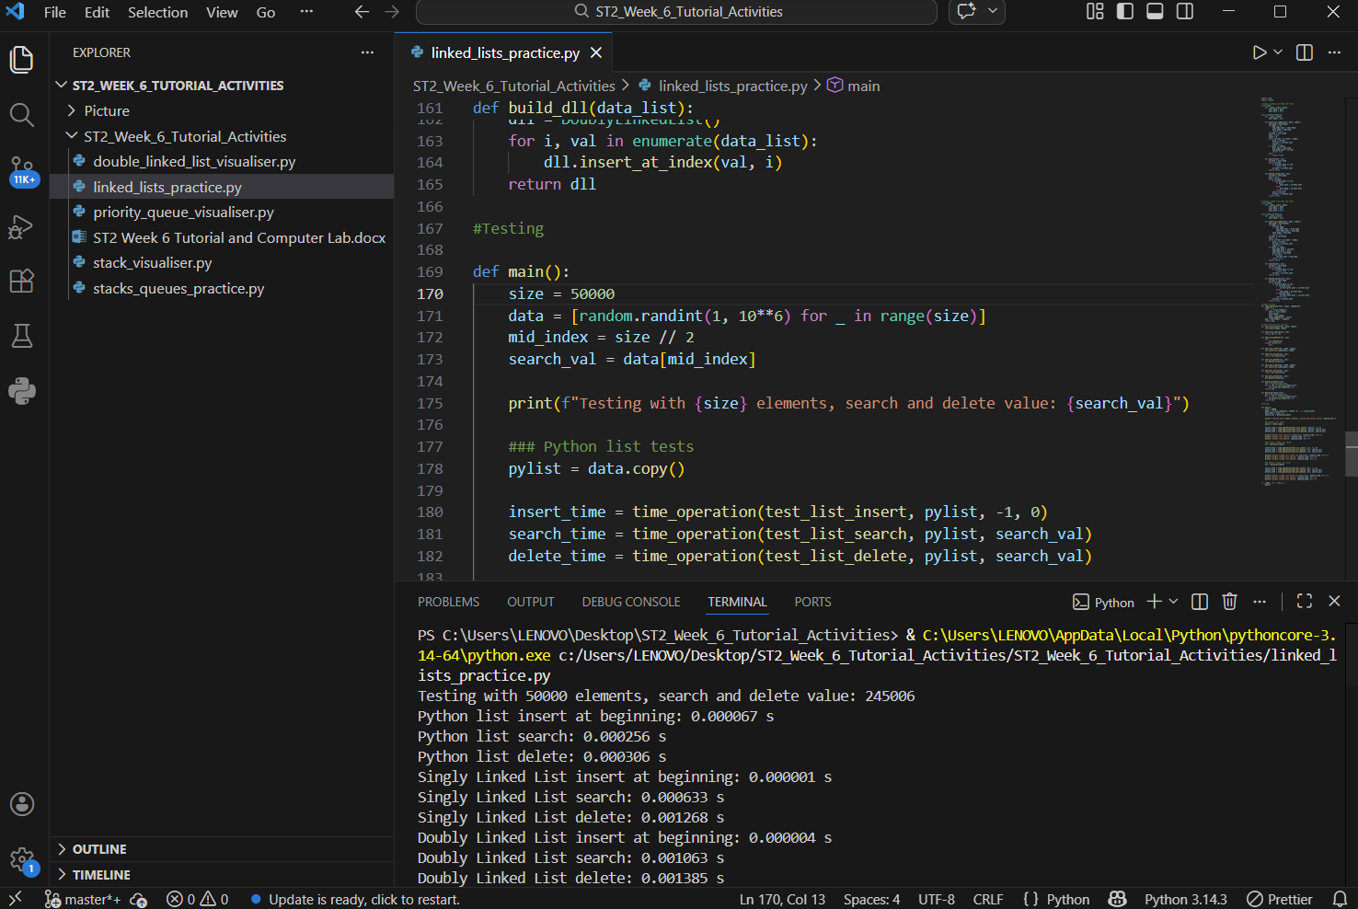
Run the script stacks_queues_practice.py for testing the stack, queue and priority queue datastructure code and double linked list code and comparing their performance for different data sizes. Report on the performance (screenshots) for each data size. Currently it is set for 1000. Test it for 10000 and 100000.
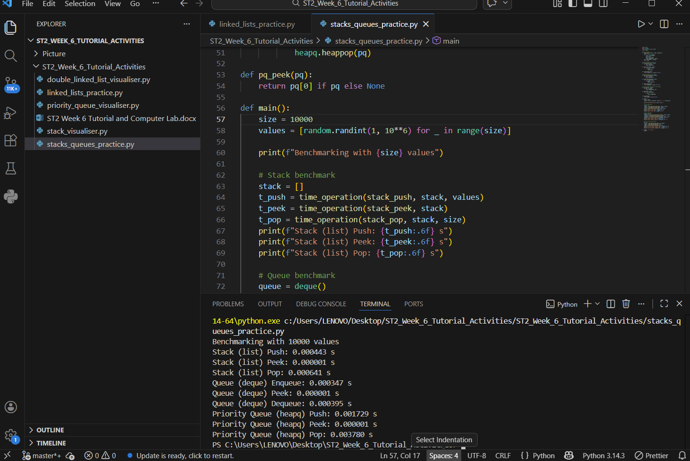
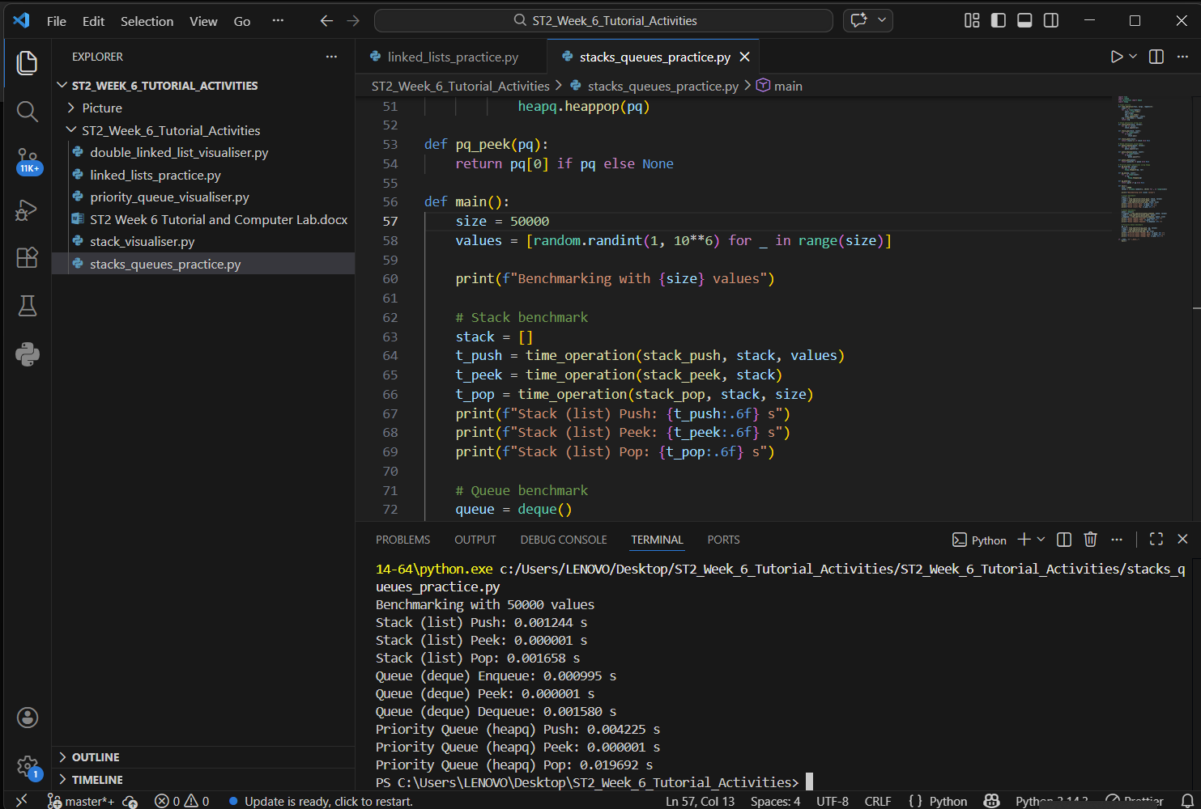

Task 2: Visualising Linked Lists
Test results (screenshots) when the Insert button inserts the value into the specified index in the dll list.
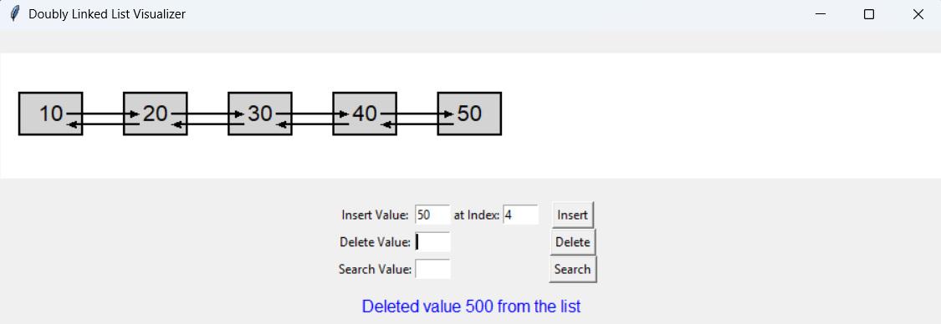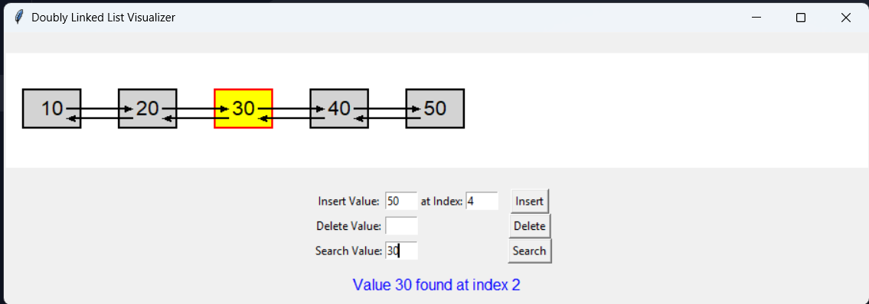

Test results when the Search button searches whether the specified value is in the dll list.
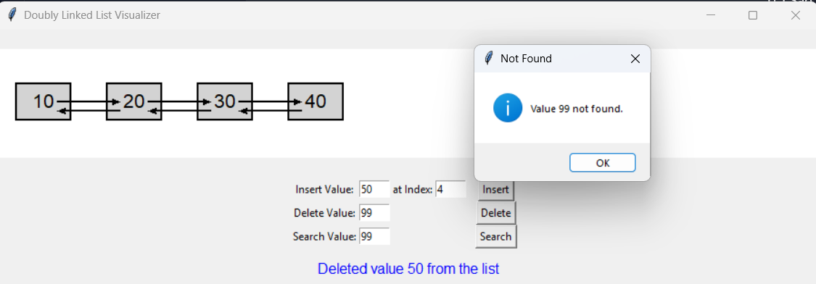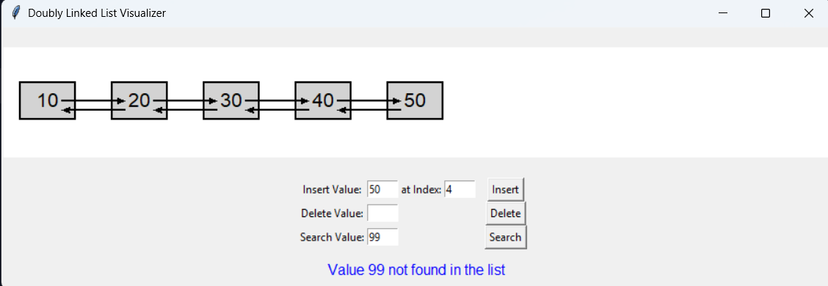

Test results when the Delete button deletes the specified value from the dll list. 
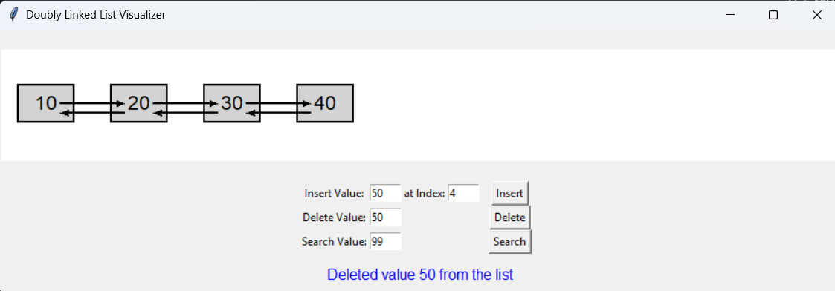
Modify the visualiser code for this task to allow visualisation of single linked list. You can use the relevant classes from Task 1 related to single linked lists to write this single linked list visualiser.
Show the GUI layout of a successful test run for this script.
Show the results (screenshots) for insert, search and delete button operations (same test data - list of integers (10,20,30, 40.50) )
Test results when the Insert button inserts the value into the specified index in the sll list.
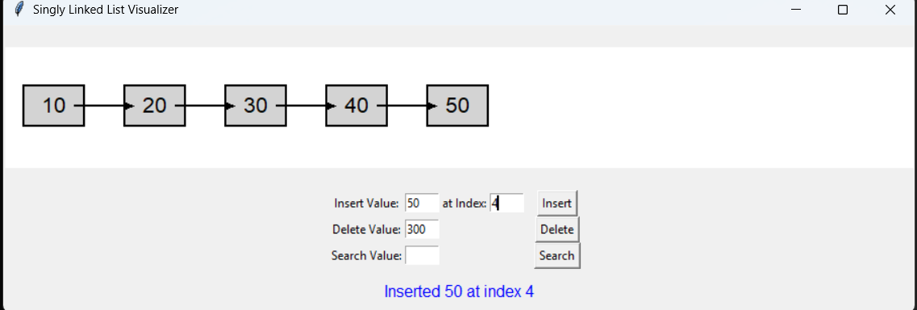
Test results when the Search button searches whether the specified value is in the sll list.

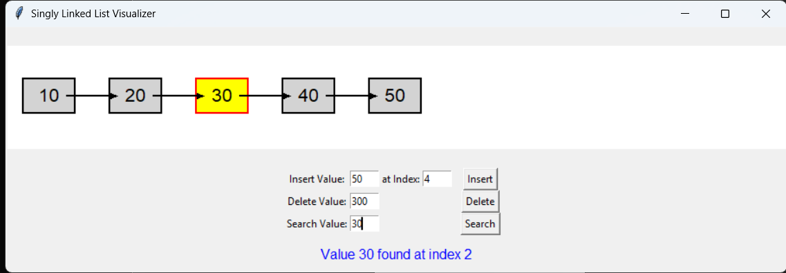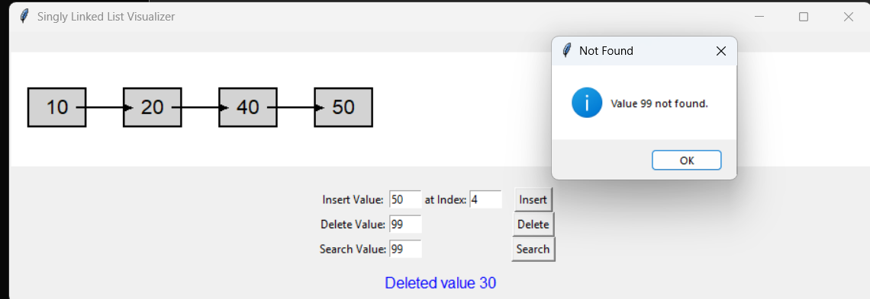
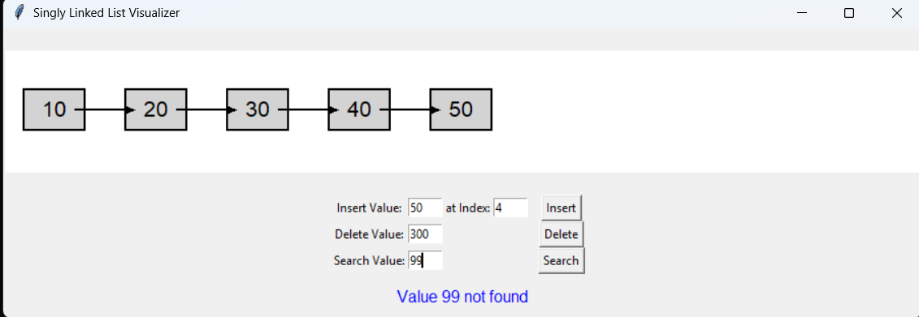

Test results when the Delete button deletes the specified value from the sll list.
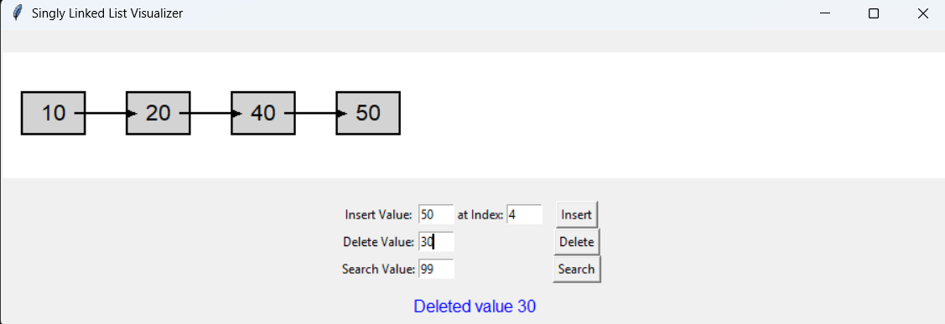

Task 3: Visualising Stacks and Queues
Test the visualiser for pushing a list of integers [10,20,30,40,50] and popping the list. Show the results (screenshots) of how the push and pop operations for a stack are performed in a LIFO order.
Test results when the Push button inserts the value in the stack
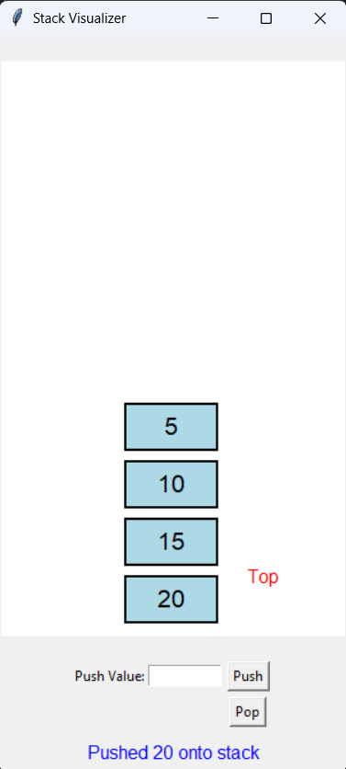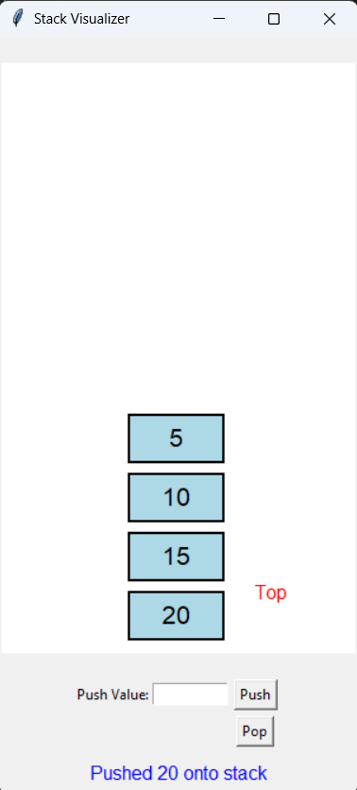
Modify the visualiser code for this task to allow visualisation of queue . You can use the relevant classes from Task 2 related to queues to write this queue visualiser.
Test results when the push button inserts the value into the queue.

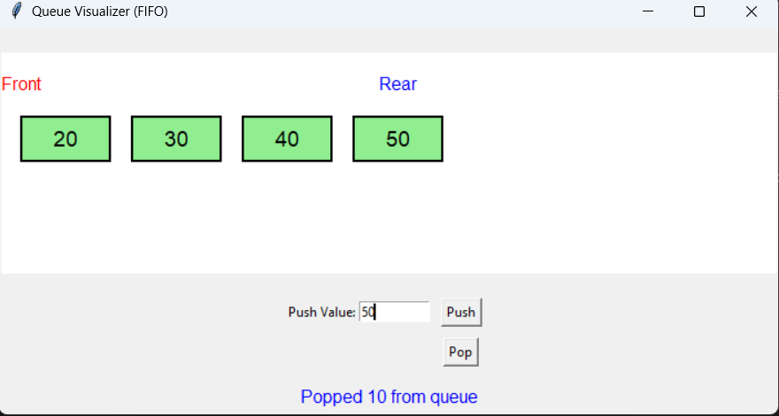
Test results when the pop button retrieves the specified value from the queue.
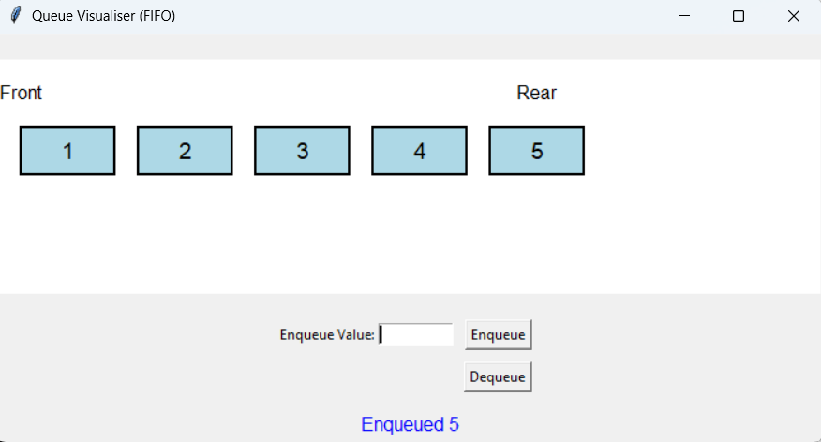

Task 4: Visualising Priority Queues
  - Test results when the Add Task button is used to insert tasks with priority value

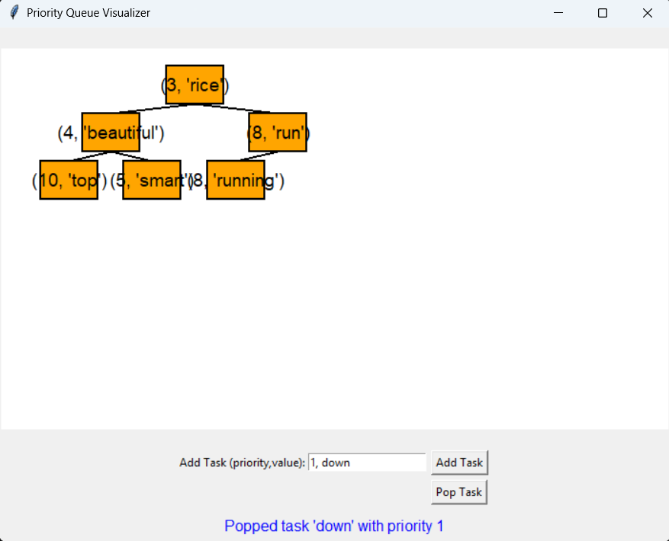

  - Test results when the Pop Task button retrieves value from the stack.

